# What Is E-Learning

**learning by utilizing electronic technologies for accessing educational curriculums outside of traditional classrooms**.

**A learning system based on formalized teaching but with the help of electronic resources** is known as E-learning. While teaching can be based in or out of the classrooms, the use of computers and the Internet forms the major component of E-learning.

* **E-learning can be carried out via the consumption of videos, PDF documents, slideshows and word documents. Thanks to the availability of these resources, it’s incredibly easy for anybody to teach themselves a new skill at their own pace.**

**Terminology / Terms**

* **4 stages of eLearning course development**
* Analysis. In the analysis phase, a course creator must remember to do an in-depth study of the target audience.
* Design and develop.
* Course evaluation and testing.
* LMS hosting. (The hosted LMS is **an alternative to SaaS learning management systems**. This is where you have to install hardware or software onto your device to access training courses, which means that a lot of times, accessibility to your learning tools is limited.)
* **Types of E learning platform** 
  1. Synchronous Online Courses - Synchronous learning means that **although you will be learning from a distance, you will virtually attend a class session each week, at the same time as your instructor and classmates**. The class is a firm, weekly time commitment that cannot be rescheduled.

**Example -** Educational video conferences, interactive webinars, chat-based online discussions, and lectures that are broadcast at the same time they delivered

* 1. Hybrid Courses - Hybrid courses **offer you the advantages of online education as well as in-class learning**. Usually, in this format, you get to learn a section of the curriculum in-person, inside a classroom, while some parts are instructed in online classes.

**Example –**in USproviding lectures on online as well as offline mode and started as Hybrid as well in which 2 day online and 3 day offline classes they introduced it is also called as combination

* 1. Providing Continuity - Continuity E-Learning is **the experience students will have when school remains in session, but when students are not allowed to physically attend school because of an unforeseen school closure event**, like the (COVID-19) Pandemic. Distributing Materials.
  2. Creating Content. - The procedure of creating content in an e-learning **determines the usefulness of the module so developed**. E-learning content development process is the most important part of the complete e-learning creation.
  3. Curating Content - Content curation in eLearning is **the process of collecting and filtering relevant information about a particular subject matter and presenting it in an organized way**. The process benefits your learners, as it helps save them time from reading through irrelevant information to get what they need. **(Not Mandatory)**

**Methodology**

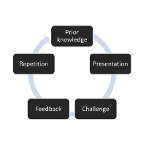

# KT/ Domain knowledge-

* **Domain** - E-learning
* E-Learning Websites

1. Bartleby
2. Khan Academy (US)
3. Vedantu
4. Udemy
5. Unacademy
6. Skill share
7. EdX
8. FootPrint
9. Splash Learn
10. Byjus

* **Application –** byjus, Unacademy, Akash-Byjus, Khan Academy

# Project-

* Project 🡪 E-learning

# Project-

**Q. Tell me about your project? Tell me Business and technical flow of your project?**

## Business Flow-

* Project domain – **Education (**Edtech, distance online education, mobile learning**)**
* Project Name – Bartleby
* Client name – **Barnes & Noble**
* **Client business** – Sell the Learning Plans, Online/Offline/Hybrid Courses to student and Earn revenue from it. Bartleby also coordinate with some schools and teach courses to students as per agreement with schools.

**Business flow –**

**Bartleby**

Sell Course to small/medium scale Tutors with bond and limit

Sell Course to School/ Colleges/ University with collaboration and approvals

Sell Course to Students/ Parents

Charity/Donation through End User/Customer

**Revenue**

* When student search for online courses on website or search colleges on Social media then their details with email ID, contact saved to data base of Bartleby/Un-academy
* That data is stored in data base and distributed to volunteers to call the students/Parents and after calling their details are distributed in following category.

1. Diamond lead (Rank 1 interested)
2. Gold lead (Rank 2 interested)
3. Silver lead (Rank 3 interested)
4. Metal Lead (Rank 4 interested)
5. Interested for next year
6. Closed/Not interested/drop

* After calling through business Associate through CRM Application
* CRM Application/Business Application/Student Relation App (**Customer relationship management**) – **Customer relationship management is a process in which a business or other organization administers its interactions with customers, typically using data analysis to study large amounts of information.**

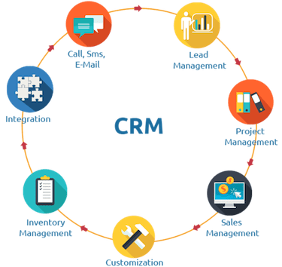

## After calling to student / Parents and finally if they buy online course then They categorised as following

1. **Annex Level 1 (Access) Level 1 Student/Role 1 (Example:) -** As **Annex** level 1 students buy course with One year Package that’s why they have following access
2. Live Lectures
3. Recorded videos in students log in with Permanent Access
4. Curriculum with last 5 years of question paper with Solution/ Sample Papers
5. Online pdf of books / Assignment
6. Weekly Test with guidance sessions
7. If buy hybrid course can visit class twice a week
8. Buy course virtual only then can attend through Tab/laptop/mobile/Web based Application Types of books
9. **Annex Level 2 (Access) Level 2 Student ()/Role 2-** As **Annex** level 2 students buy course with 3 months/6 months Package that’s why they have following access
10. Online Lectures only
11. Recorded Videos with temporary Access
12. Last 2 Year Question Papers with Solutions/Sample Papers
13. 2 Test in a month
14. Hybrid/Combination option not available for the course
15. Access Curriculum /Types of books
16. **Annex Level 3 (Access) Level 3 Student ()/Role 3-** As **Annex** level 2 students buy course with 1 months/20 days Package that’s why they have following access
17. Recorded video lectures only
18. Last Year Question Papers without solution (only 1)
19. 1 Test Only
20. Curriculum
21. 1 Guidance session at last day of course/ Types of books
22. **Annex Level 4 (Access) Level 4 Student ()/Role 4-** As **Annex** level 4 students those who have do Registration, create account and Profile on Application and those who booked **free** demo. They have following access
23. Free Recorded video Lecture (1 for each subject)
24. Last Year Question Papers with Solution (only 1)
25. All courses broachers
26. Curriculum
27. 1-week free trial with course contents/ Types of books

## Technical Flow -

Students /end User/ **Buyer**

Register for Bartleby through website Advertisement/social media

Students /end User/ Buyer Data **Saved in Database**

City 1/District Business Associates

City 2/ District 2 Business Associates

City 3/ District 3 Business Associates

When Associate Reach to student then student Registered Through Web based Application

Lower Category -LKG/UKG 1st to 4th Course Selection

Lower Middle Category – 5th to 10th Student

Middle Category – Entrance Exams for Degrees

Upper Middle Category – 11th & 12th Student

Graduate Students – MBA, Engg, Medical Science, Computer Science, etc

Database

API Students (Who buy Course)

Access Level 1

API Students (Who buy Course)

Access Level 1

Payment Process Students Through Cart

Payment Process Through Students Cart

API Students (Who buy Course)

Access Level 1

API Students (Who buy Course)

Access Level 1

Teachers/Executive/ Associate of Bartleby

**Annex** Level 2 Students (Who buy Course For 3 month/6 months Access Level 2/Role 2

**Annex** Level 1 Students (Who buy Course For 1 Year) Access Level 1/Role 1

Business Associate

CRM

Access Level 1

CRM Students (Who buy Course)

Access Level 1

API Students (Who buy Course)

Access Level 1

API Students (Who buy Course)

Access Level 1

Database

Database

**Last Annex** Level Students (Who booked free trial and create Profile only) Access Level Last/Role 4

* When student/end user Register for Bartleby through website Advertisement/social media then end users, data stored in database.
* The Students/Parents data distributed to business Associates from different cities.
* After calling done from Associates students can Register/Create Profile Through Web based Application (sometimes students can register directly)
* As soon as they completed their registration they are categorised as Lower Category -LKG/UKG 1st to 4th Lower Middle Category – 5th to 10th Upper Middle Category – 11th & 12th Student Middle Category – Entrance Exams for Degrees Graduate Students – MBA, Engg, Medical Science, Computer Science.
* Students can do payments and buy a course and enrolled for classes. Students do Payment Process Through Cart.
* And as per their course amount, course duration they are categorised as **Annex** Level 1 Students (Role Level 1), **Annex** Level 2 Students (Role Level 2). And students still not buy any courses and accessing the Application for free (which is limited access) they are categorised as **Annex** Level 3 students (Who booked free trial and create Profile only).
* Business Associate are always connected to Role Level 4/Last Role students (Through calls, social media, mail etc.) **CRM**; and giving them course information as well as motivate them to buy a course.
* Teachers and Executive are always connected to Access Level 1/Role 1 & Access Level 2/Role2 Students to teach them, to solve their queries.

**User Story –** When Business Associate Got contact details of lead, he should able to do video call, Telephonic call to lead through his web, and able to send, **Send Email.**

**Acceptance criteria**-

1. Multiple options should visible on dashboard of CRM Application which contains features like Video calling, Audio calling, Text message
2. When click on video icon then pop-up comes with notification as Video call which contains question like Do you want to video call ……Name of student……? with cancel and call button
3. When click on Telephone icon then pop-up comes with notification as call which contains question like Do you want to call ……Name of student……? with cancel and call button
4. When User click on cancel button Pop-up should disappeared from screen
5. If User click on call button call started on web
6. When user click on Email icon the pop up come with Email web which redirect user to its Email account

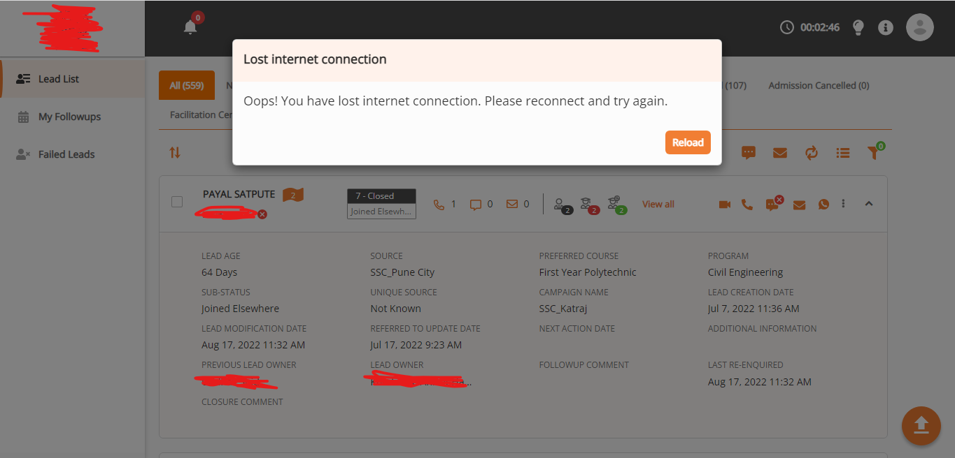

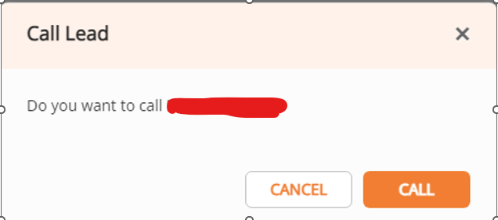

**User Story –** When Business Associate call to student then **he can mark Students Details, Academic Details, Document details**

**Acceptance criteria**-

1. After calling or on ongoing call Associate mark students details in student details tab contains Channel (mandatory field), Source (mandatory field), Status (mandatory field), Sub-Status, Lead Owner (mandatory field), Additional Information, lead status comment and send welcome email checkbox and send welcome sms checkbox. Cancel and Update button should be on page where Cancel button cancel/close window/frame and update button can update/save the information
2. On Academic details tab it shows the students academic details in which it contains information as last year marks, Graduation marks (if applicable),marks (if applicable), school/college name, Entrance exam score etc
3. On document details tab fields should be visible as Category of admission, Type of admission, document submitted & Remark

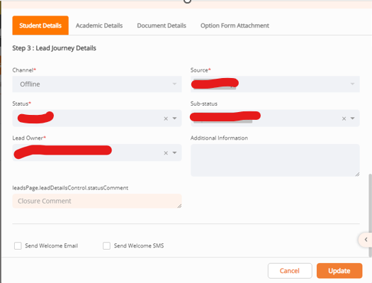

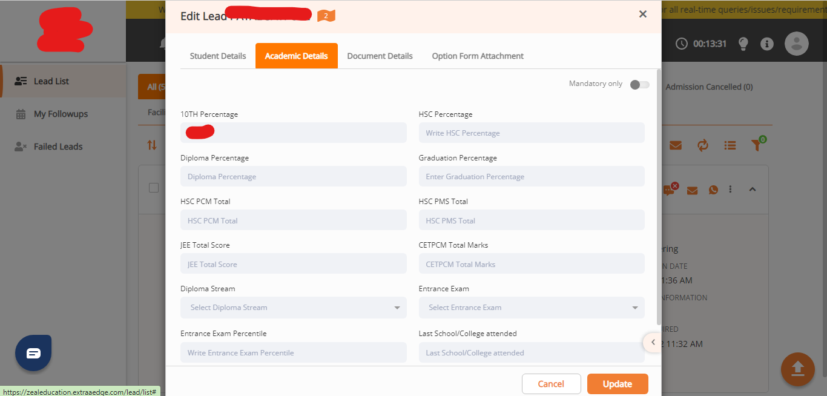

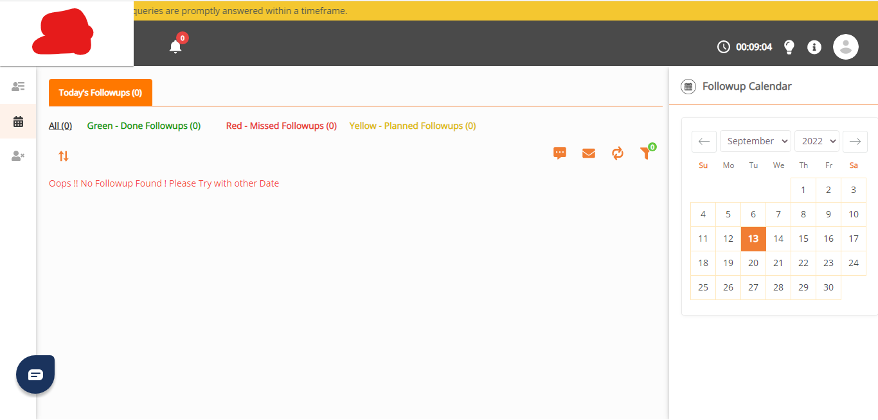



**User Story –** Business Associate can Filter Students Details like Communication details, verification details, Date filters and Range filter

**User Story –** When End User Visit to Application then he can watch demo video lessons (This access is for everyone) whenever Student/Parent can select any class from 1st to 12th he can watch 1/3/2 demo videos each.

**Acceptance criteria**-

1. Class drop-down have classes on ascending order (Like class 1 is on top and class 10 is at bottom)
2. Where there is nothing select then visible with message as “Please select the class”
3. For every classes the default value for number of videos will be 1/3/2 which means for all class video lessons have 1/2/3 video.
4. When click on particular class the videos recommendation is for same class
5. User may not be able to play both videos on same time

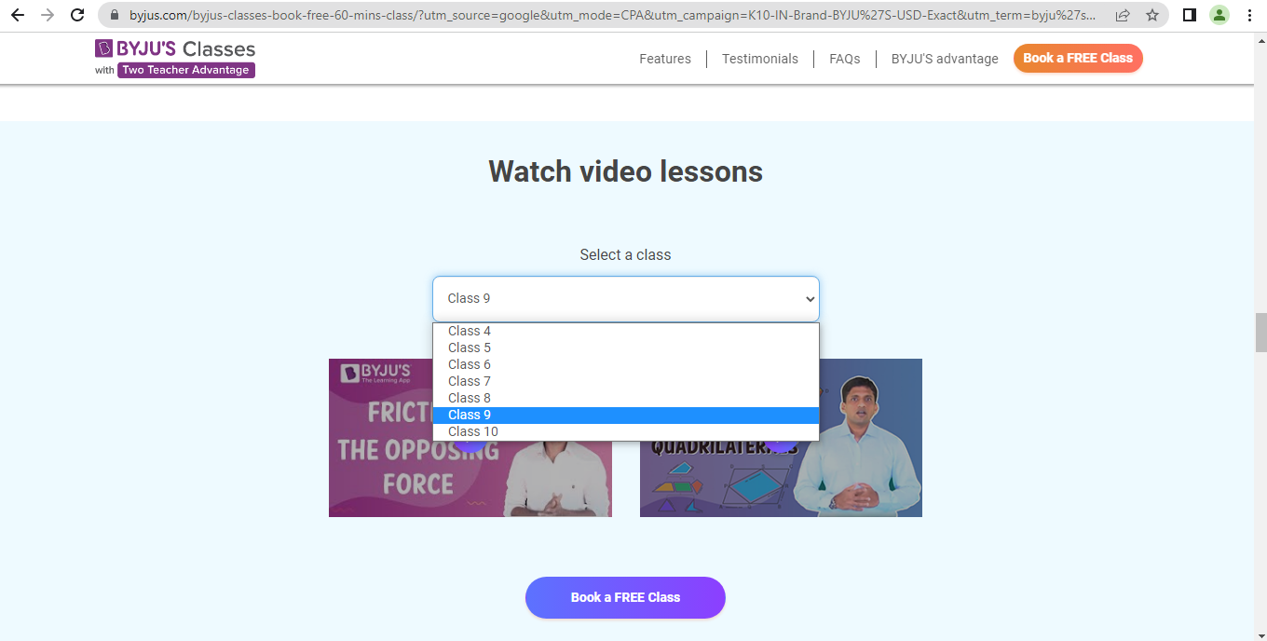

**User Story –** Book Free class/Demo class/Book Topic/Book Class

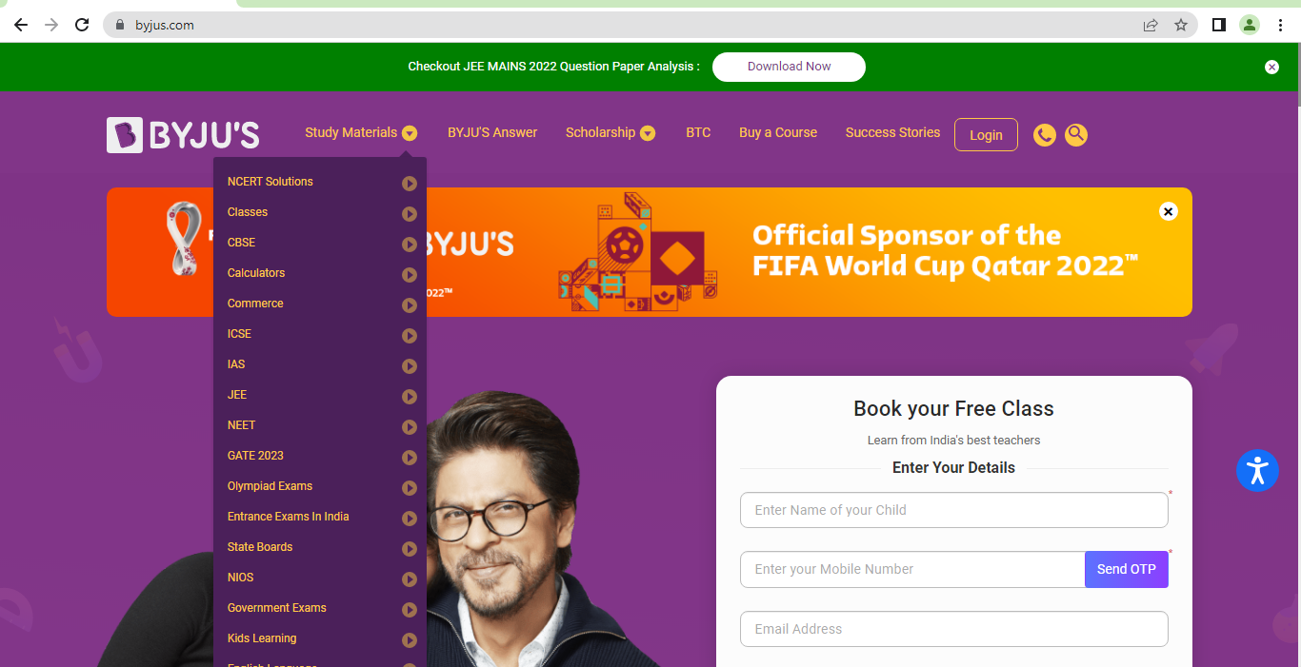

**Test Case -** Verify the error message/Notification below

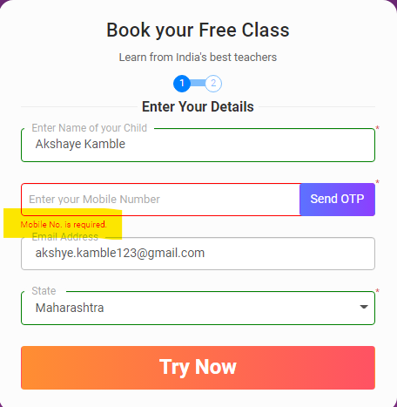

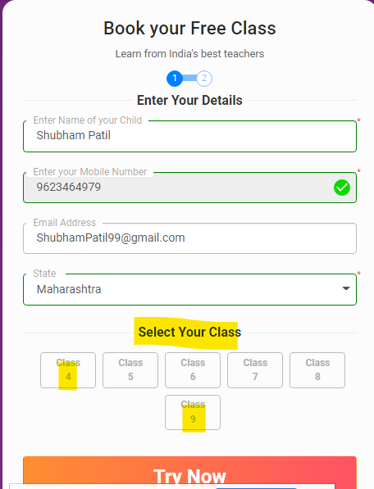

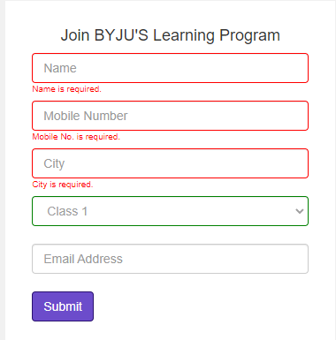

**Log in And Call**

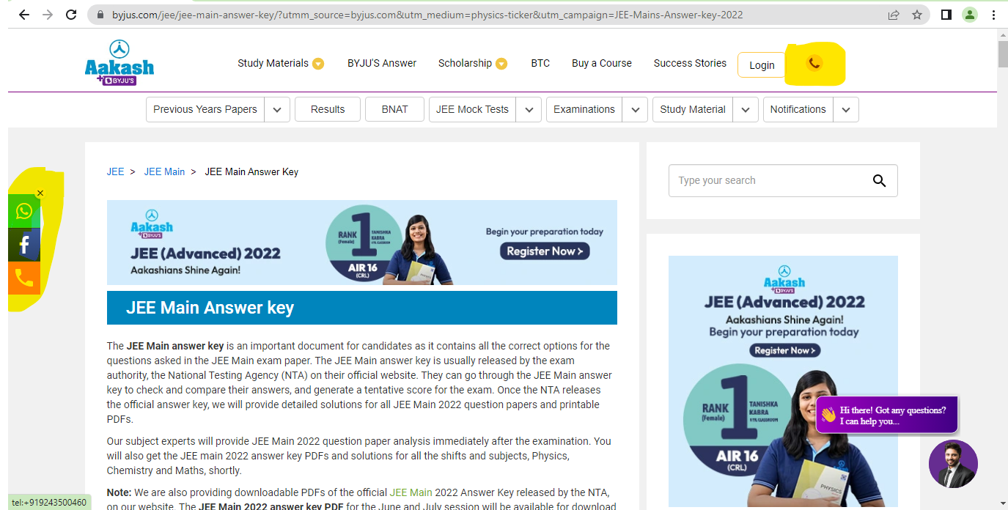

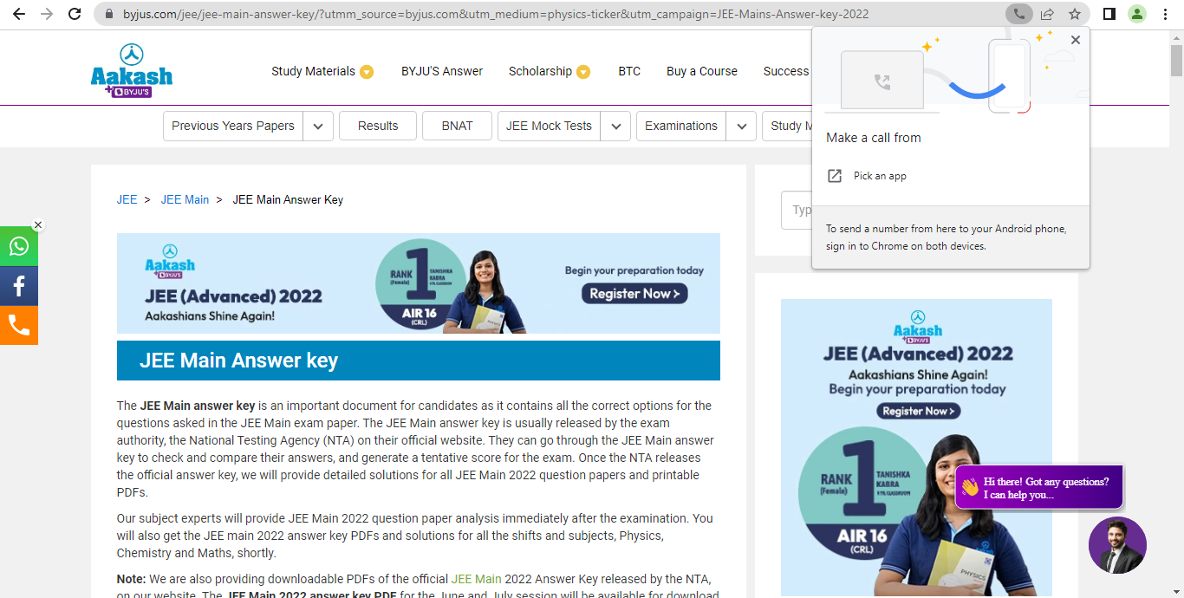

**User Story – End User/Buyers Profile**

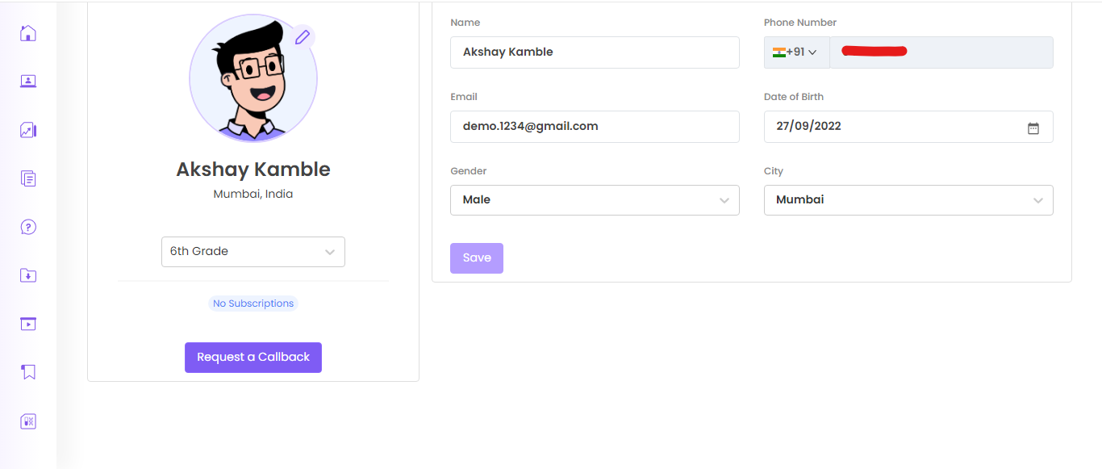

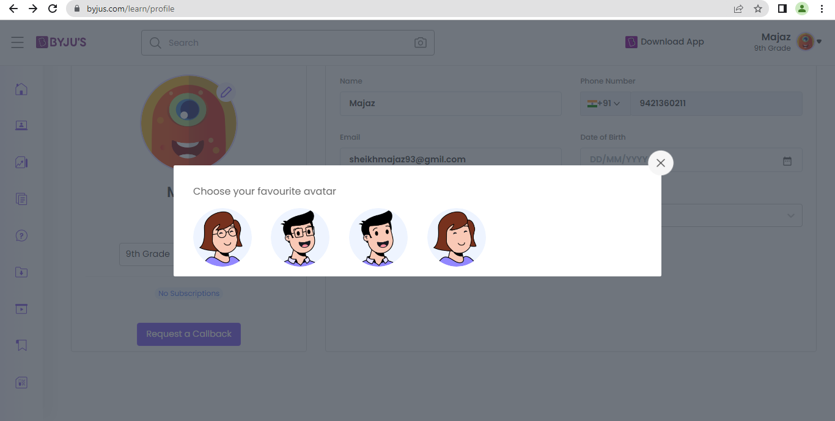

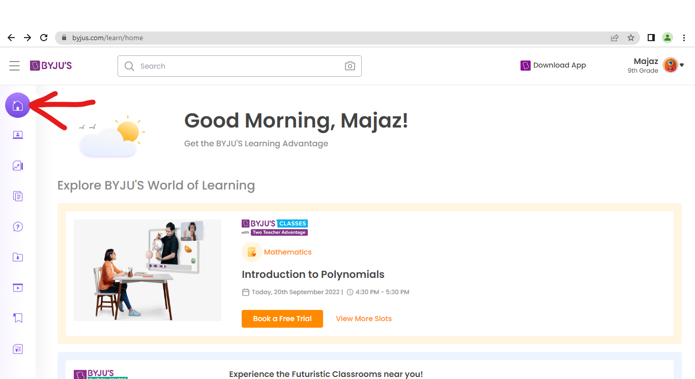

**User Story –** Quiz/Unit Test/Sample Test visible for all level students in their log in

**Acceptance criteria**-

1. When User/student visit to quiz/test 1st time start quiz button shown to them
2. Incomplete quiz the button replaces with resume quiz
3. When user visit on completed quiz/test the button replace with Take quiz/test again
4. When user click on start quiz window/pop-up open with start button
5. After click on check button for right answer can show message Nice work!
6. For wrong answer showing try again message with 2 links associated with it as help and next question

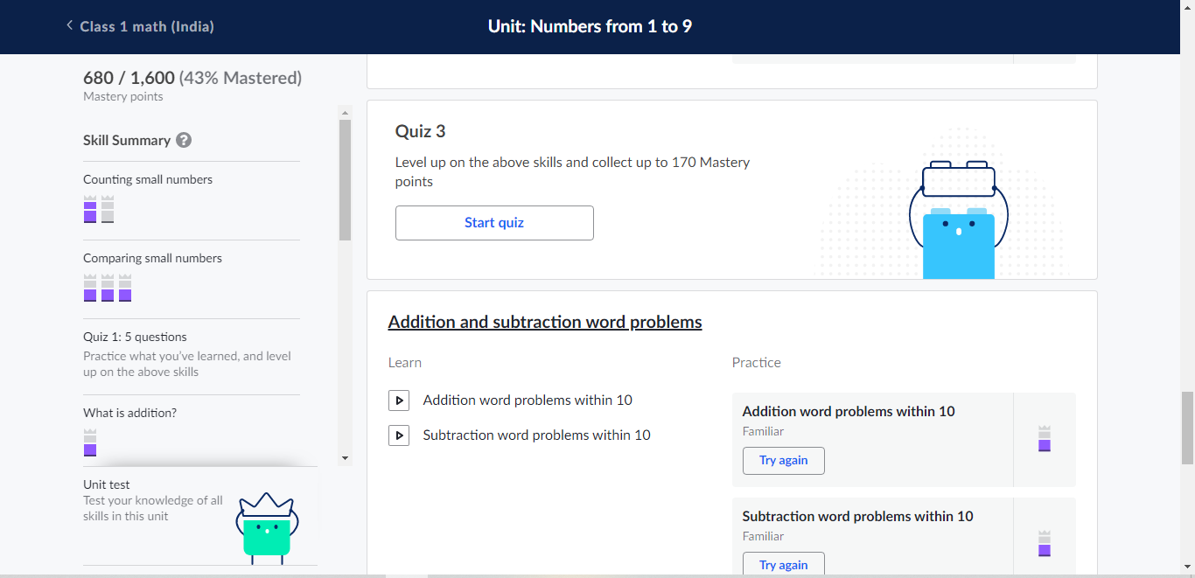

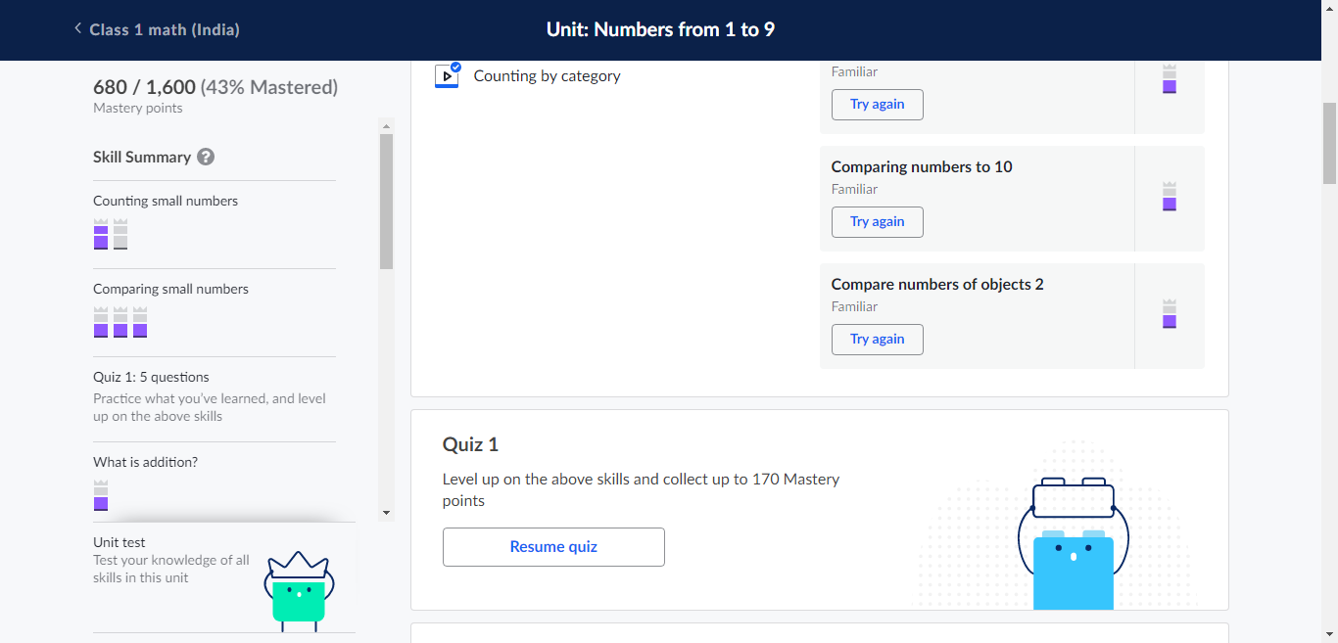

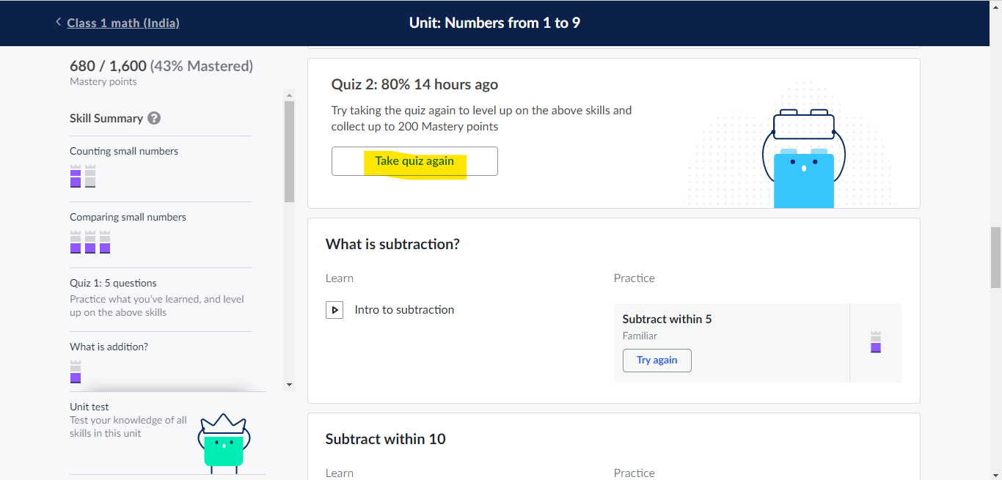

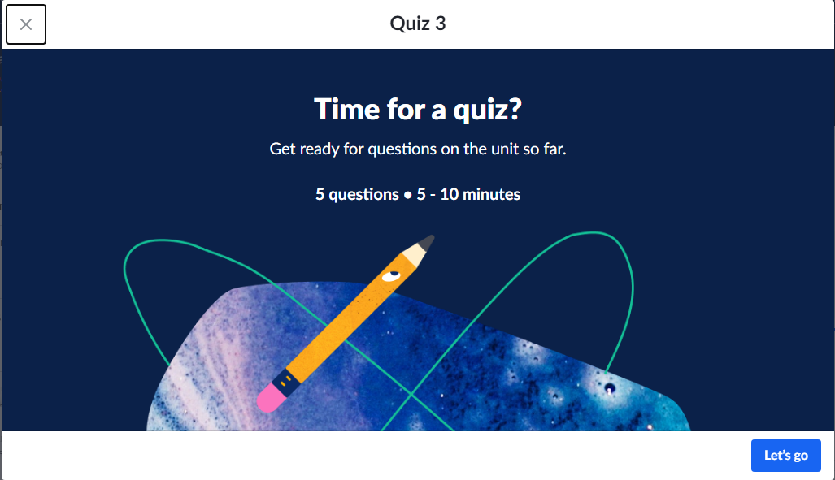

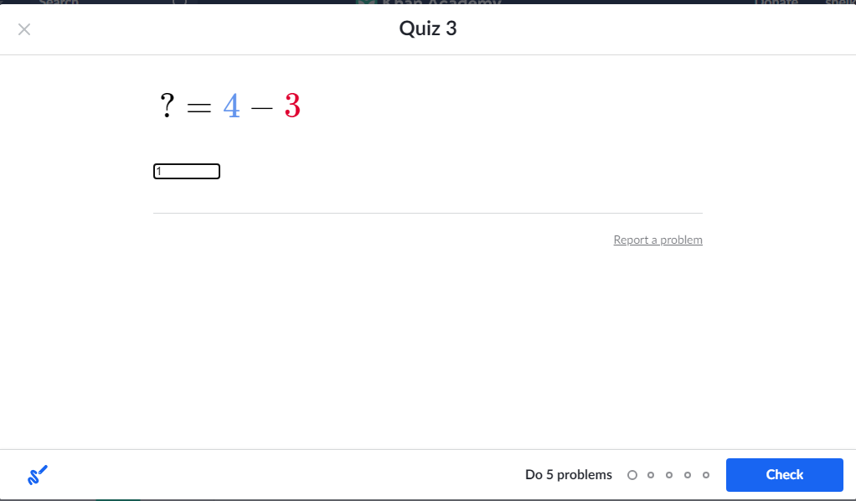

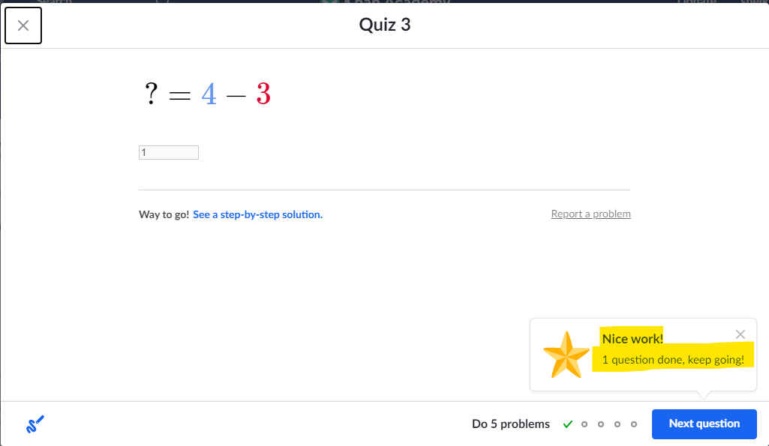

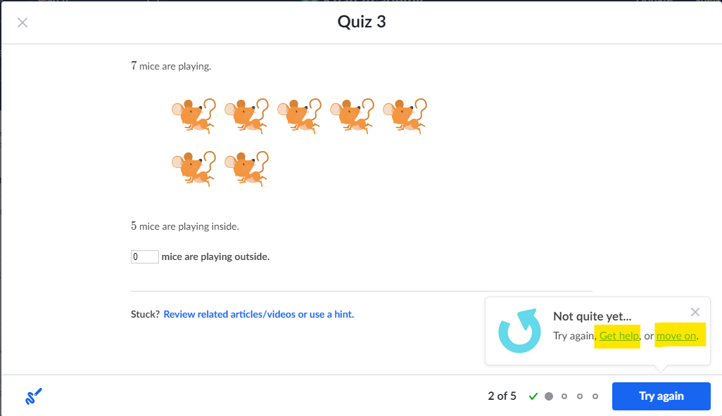

**User Story –** Users can Access Test Tab in which Test sessions contains the subjects for which grade student registered for and have option to pick a subject to start test

**Acceptance criteria**-

1. Tests section displays the same subjects for which student registered for particular grade
2. Whenever user can pick a subject or click on particular subject instruction page opens
3. For every subject on instructions page Number of Questions should be 10/12/13/15 and Countdown timer is 15min/7min/12min (which can count the time on reverse order)
4. User/student can select Chapter wise Test
5. Questions may be multiple choice questions with options have radio buttons.
6. User can complete/Submit his test **with or without completing the test**
7. User/student can see total score with summery after submit the test **and/or After time is Ends** or whenever he can visit to Test Page
8. User must have the ability to retake the test at any instance of time

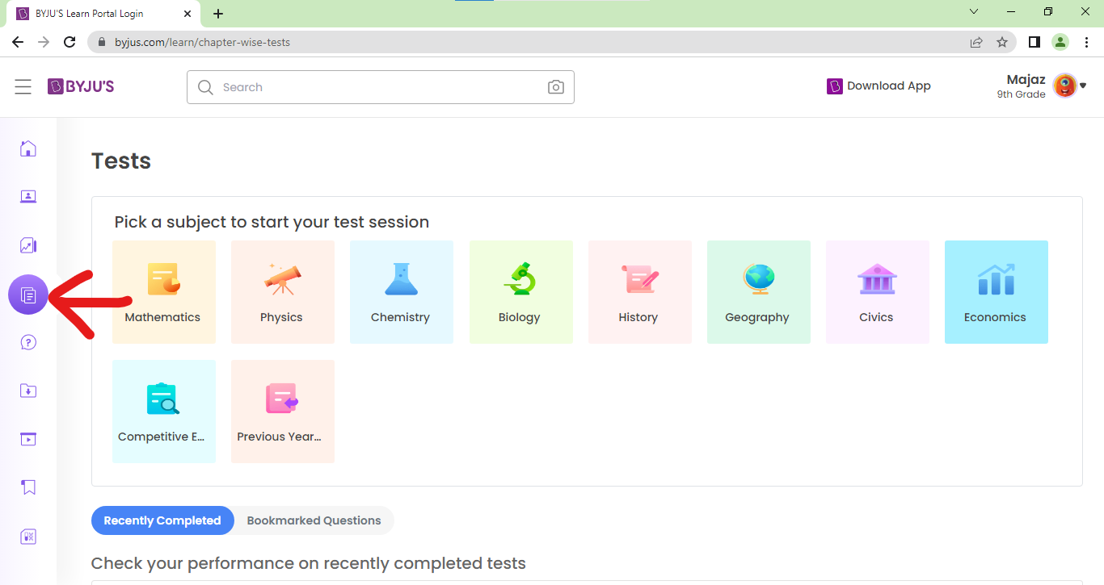

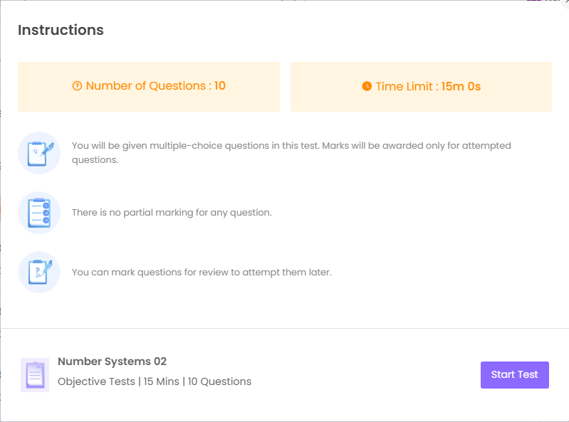

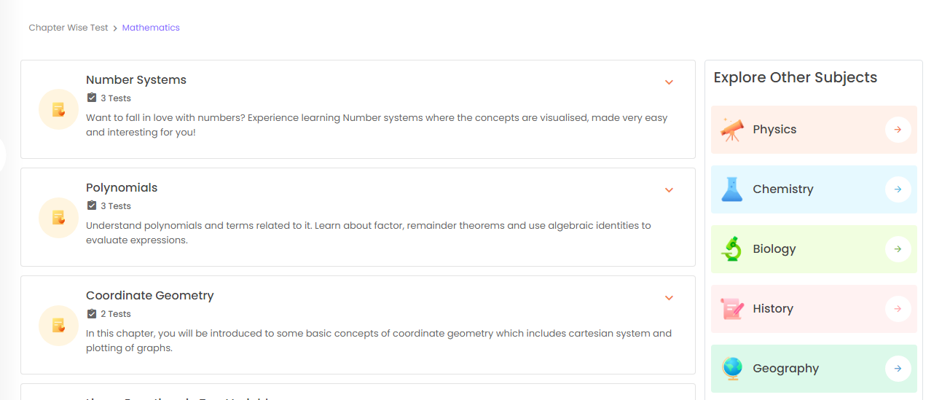

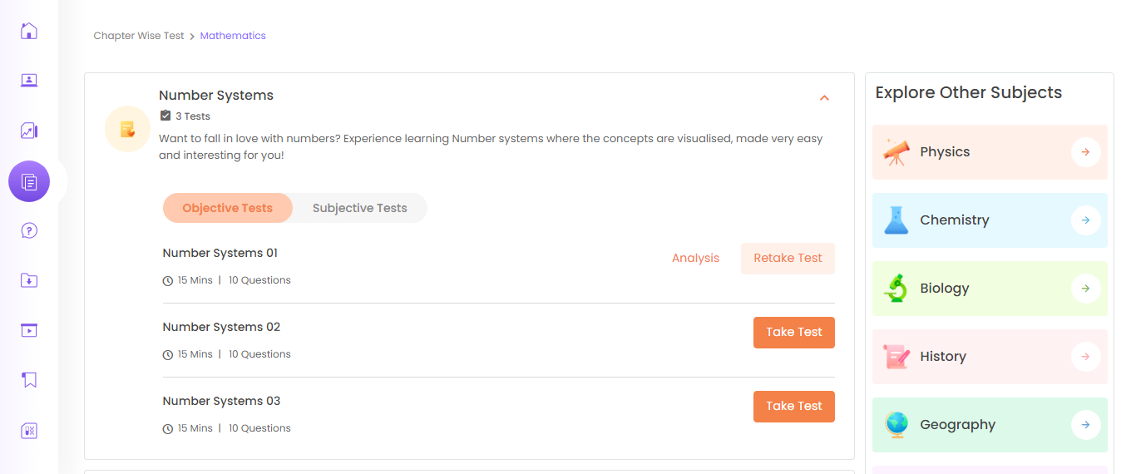

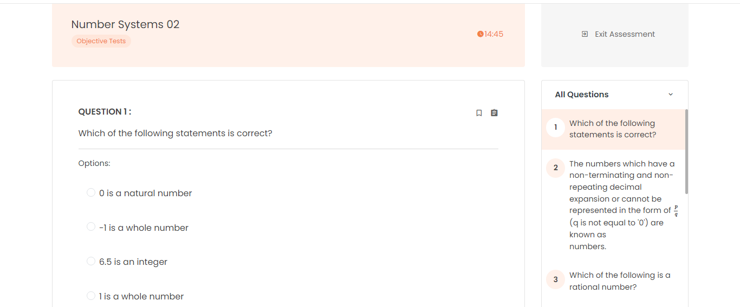

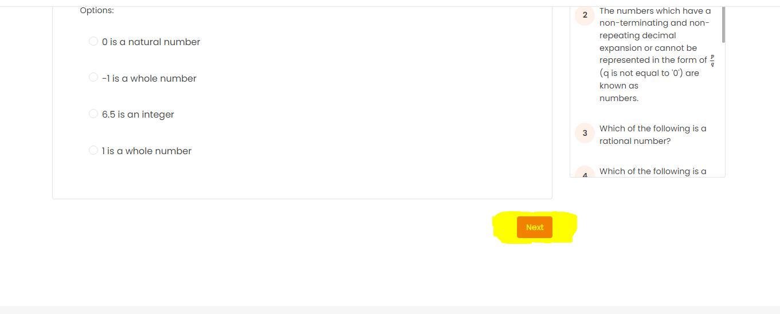

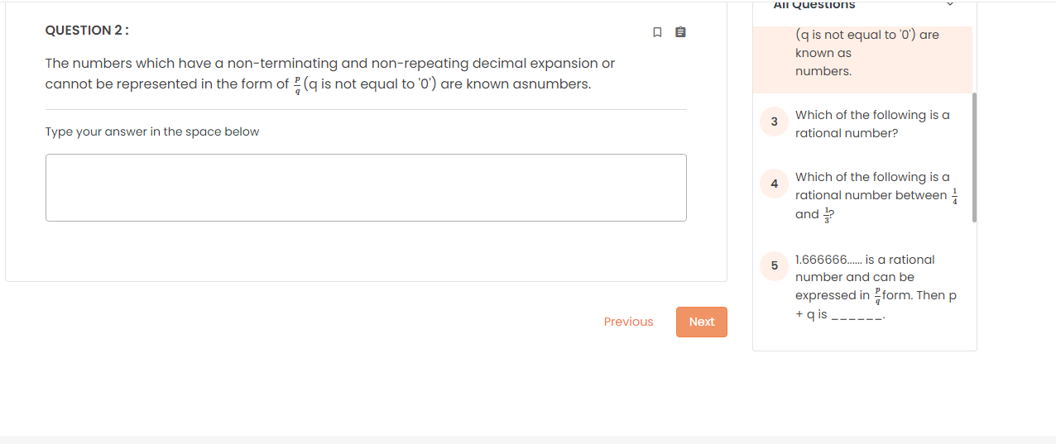

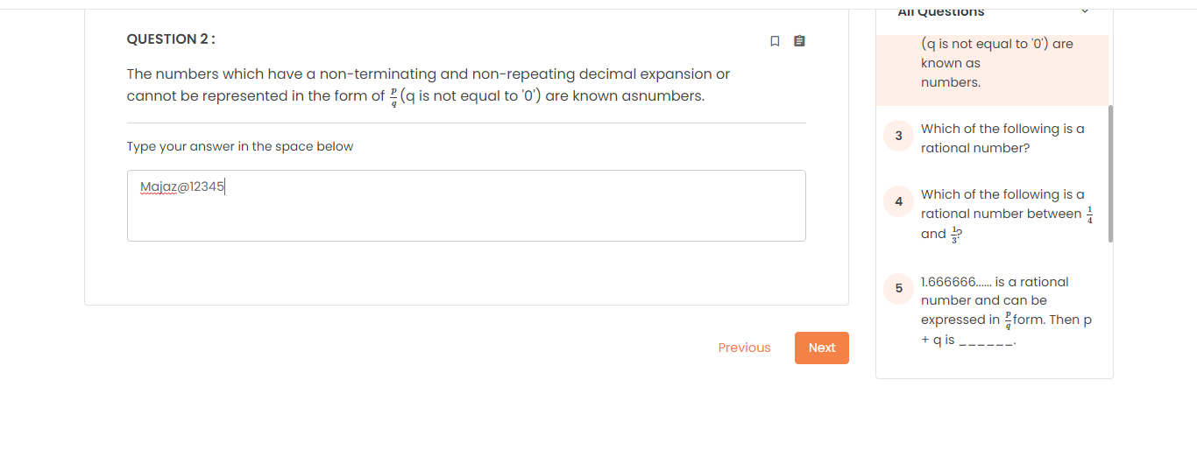

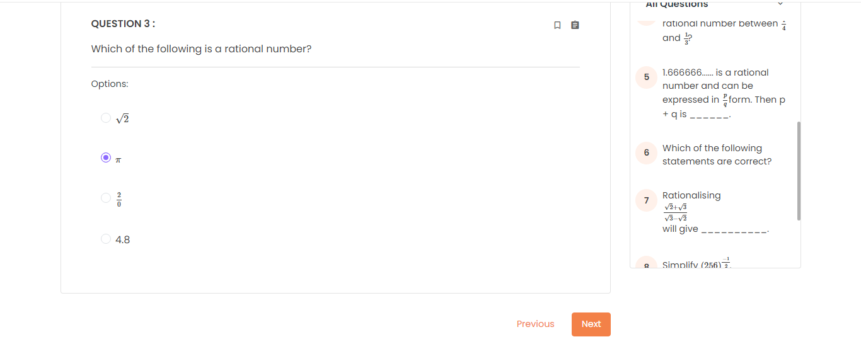

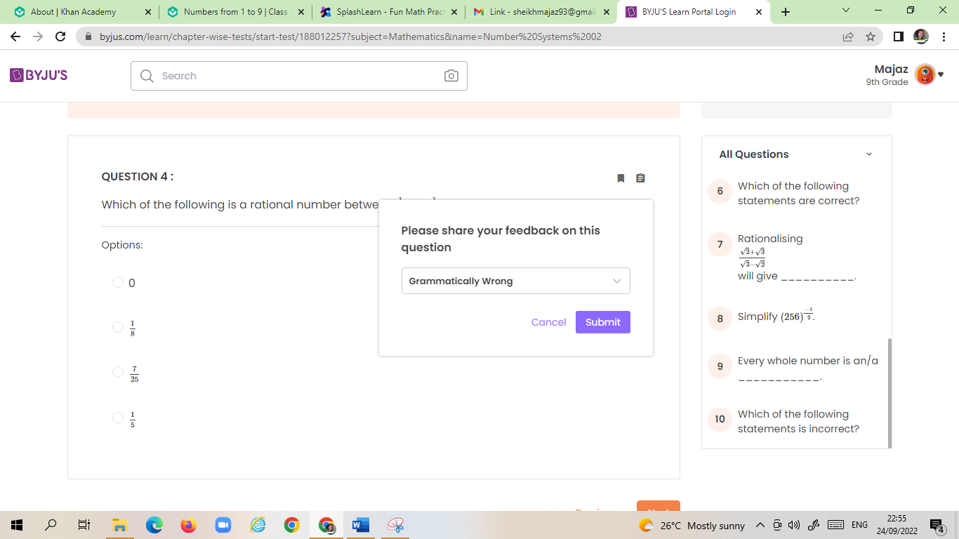

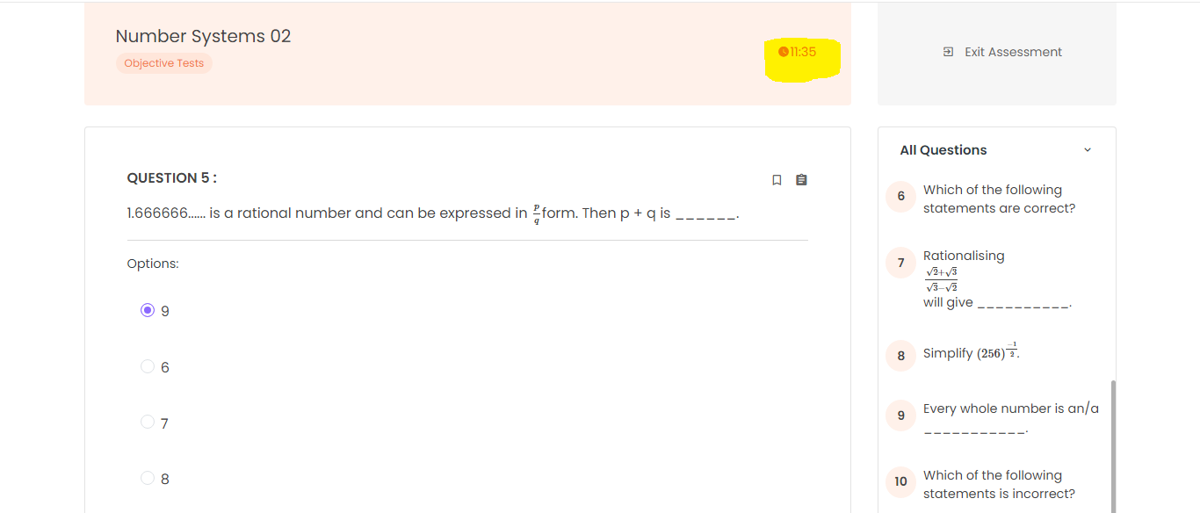

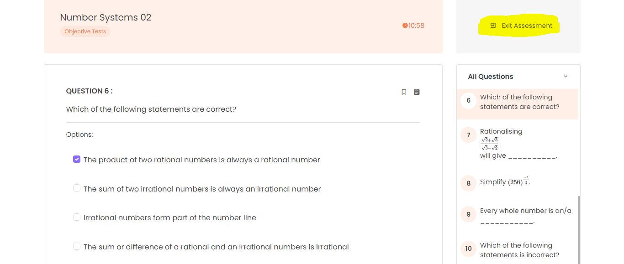

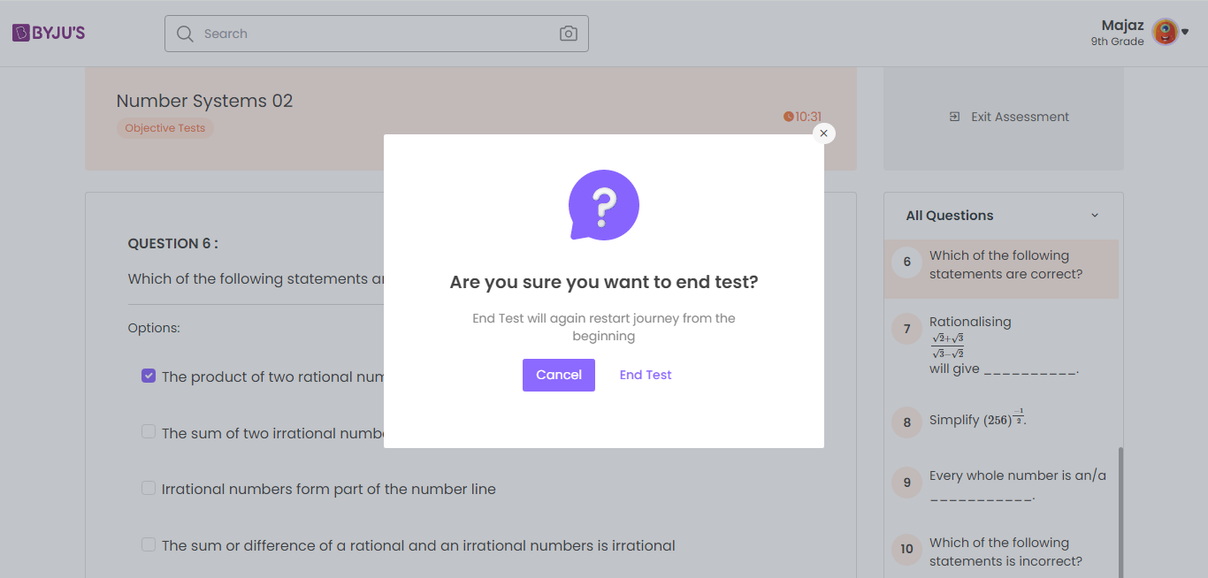

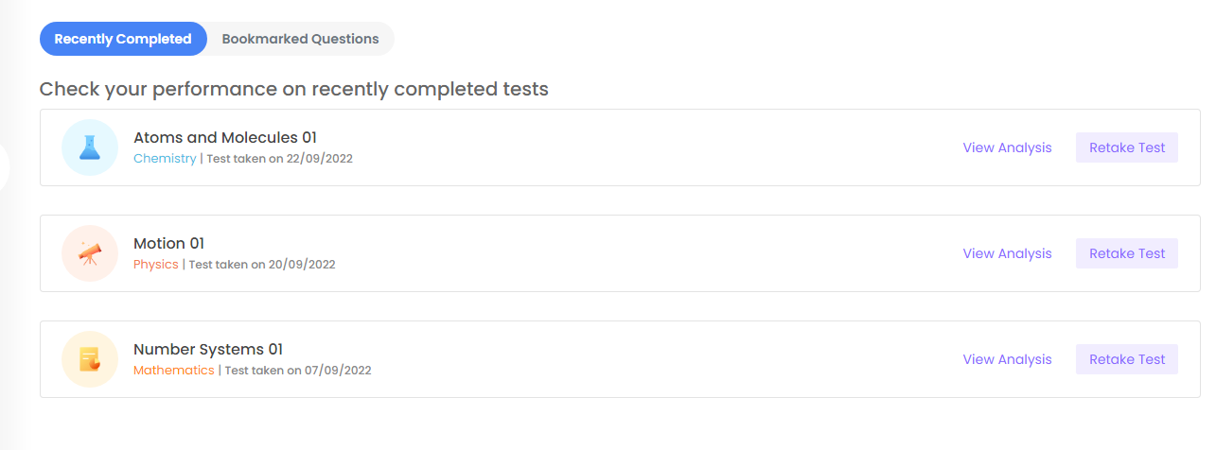

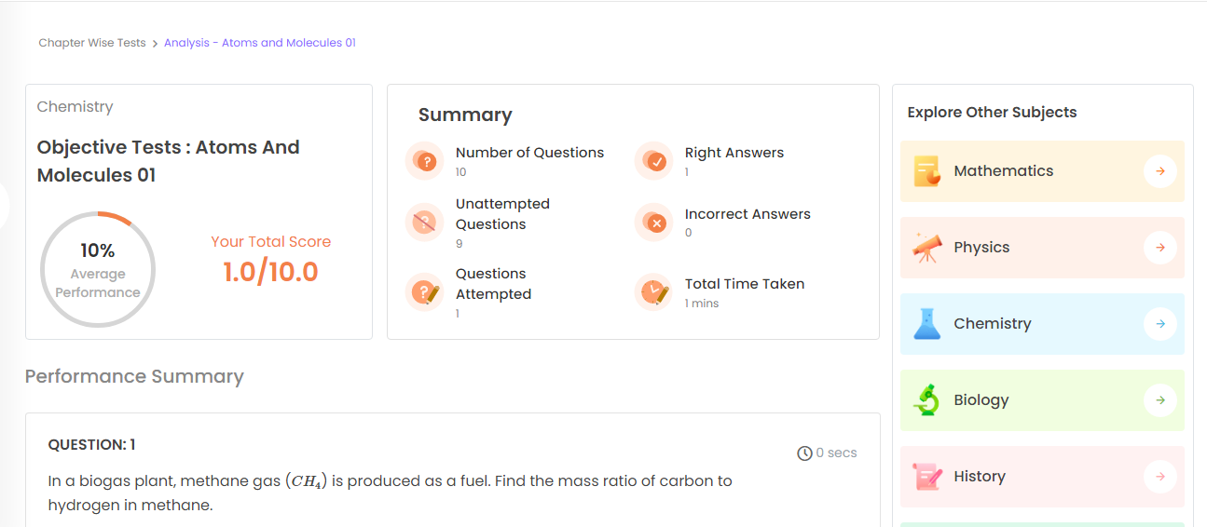

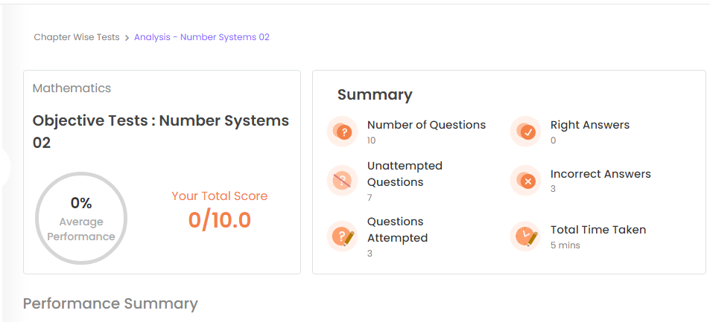

**User Story –** In downloads section user can download previous year paper/ sample paper/ Curriculum (Automation Functionality)

**Acceptance criteria**-

1. Access level/Role 1 student have the access to download of all papers from last 3 years and all sample papers / Curriculum
2. Access level 2/Role 2 student can download only last 1 year papers and all sample papers / Curriculum
3. Access level 3/Role 3 students cannot able to download sample papers when Access level 3 students tried to click on previous years paper’s or sample papers section the message/Notification should displayed as **No papers available.**

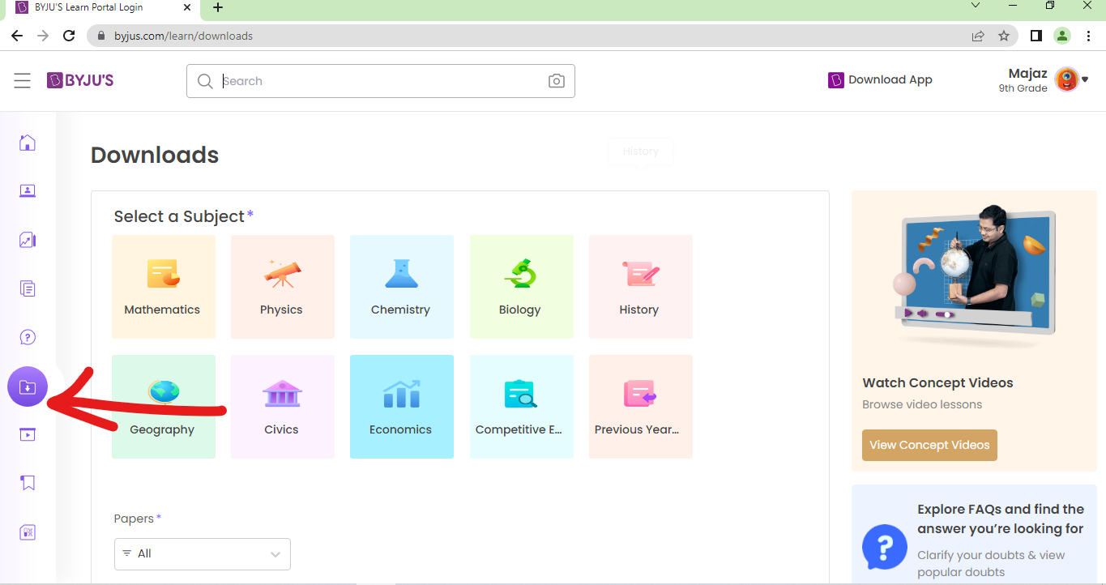

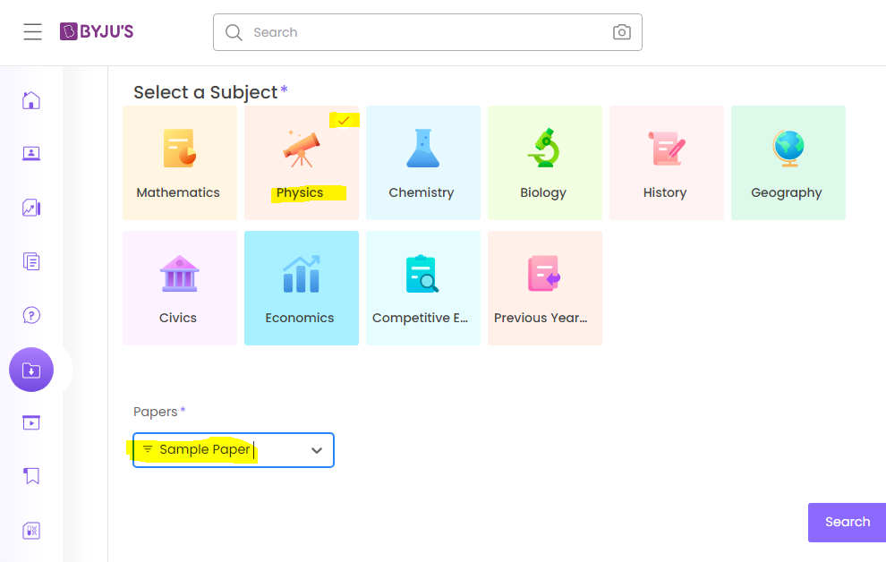

**Access/Role Level 1 & 2**

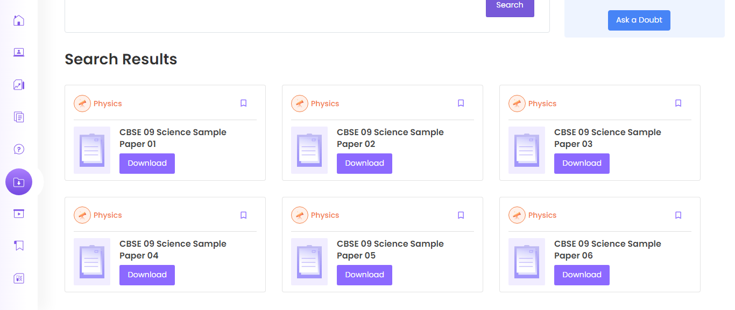

**Access Level 4/Explore Free**

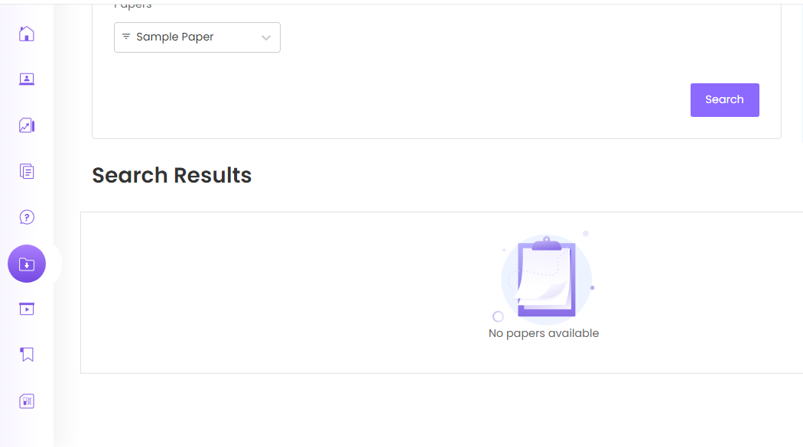

Module – Account profile

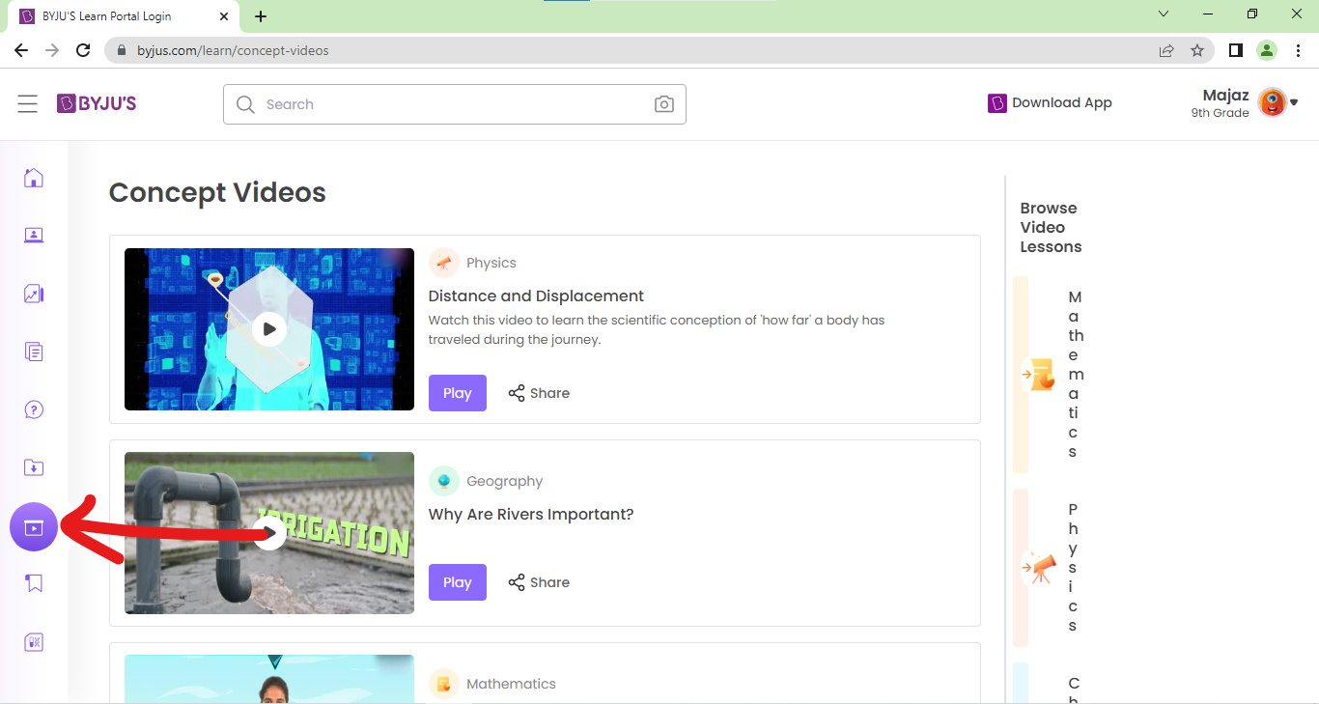

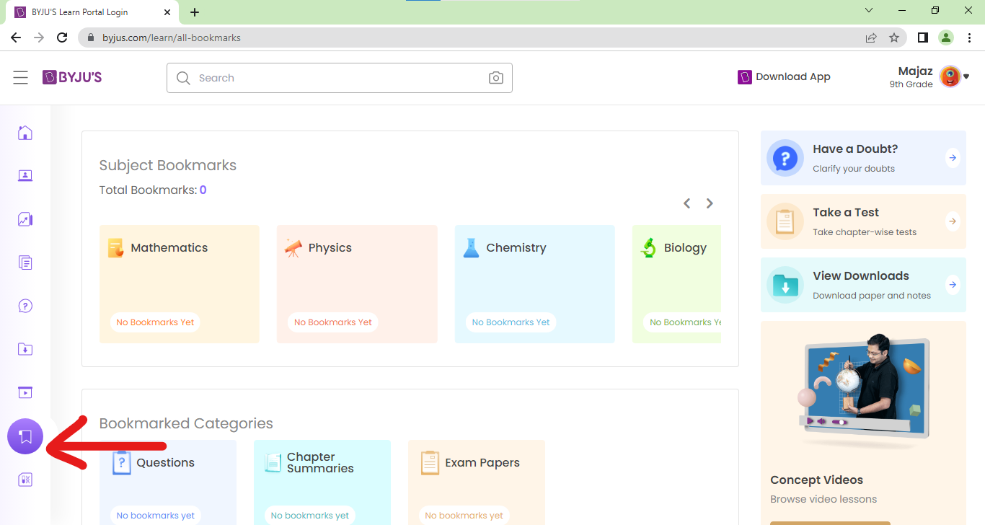

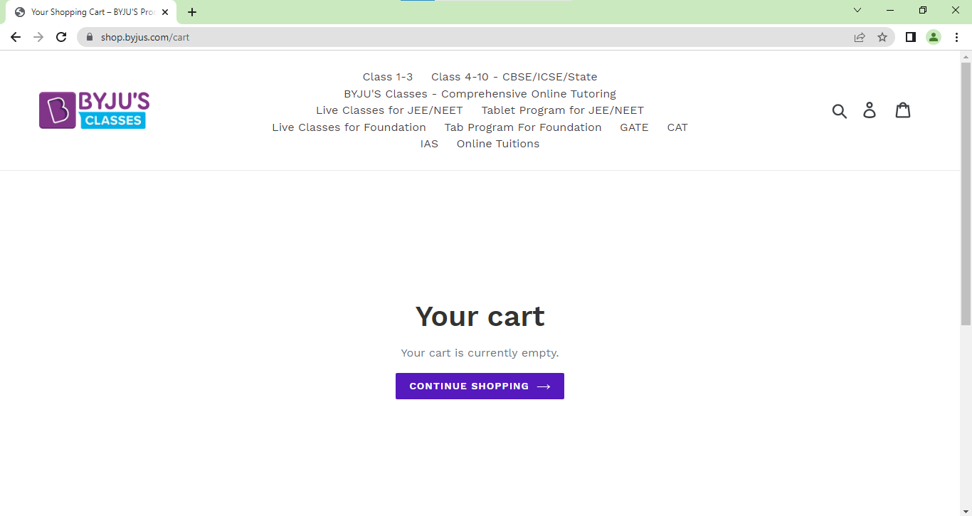

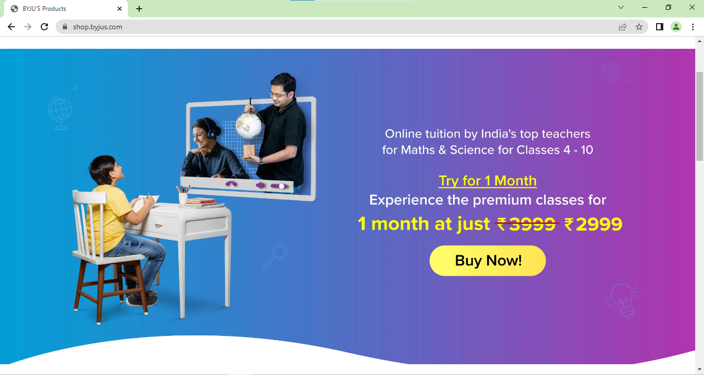

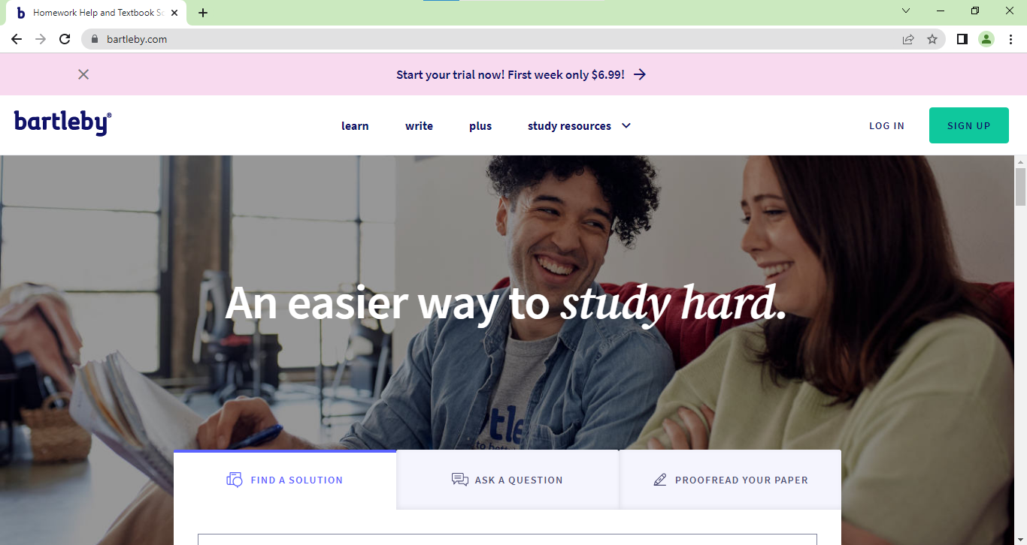

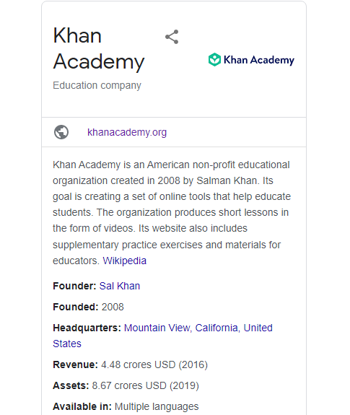

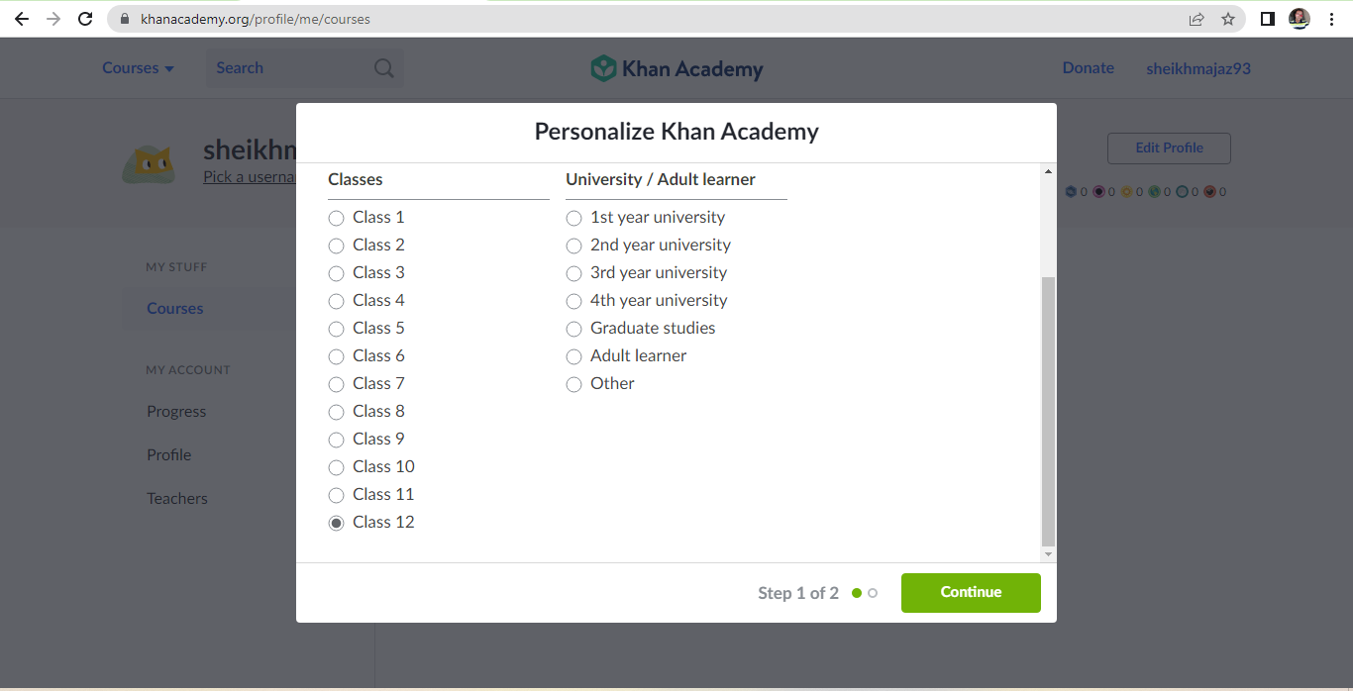

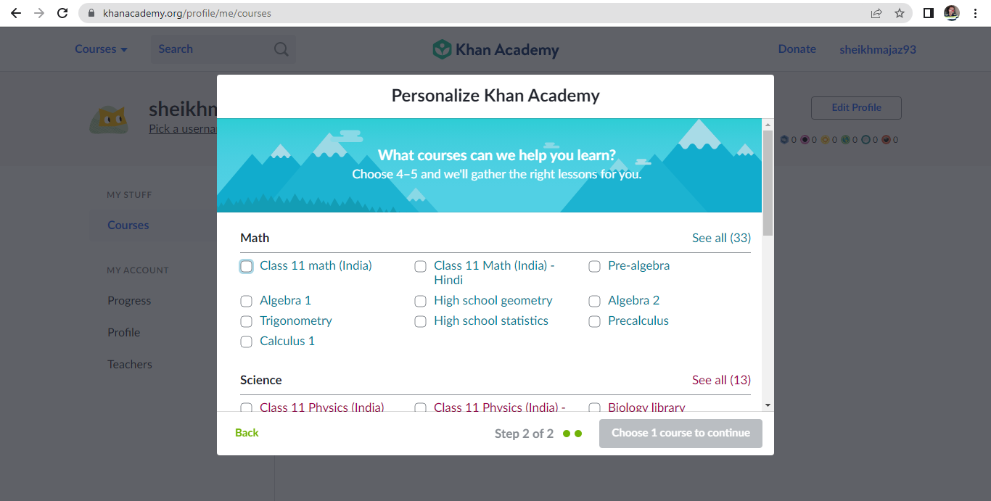

**Drag on drop functionality (Khan Academy Quiz Section for Std. 1st to 4th Students/User)**

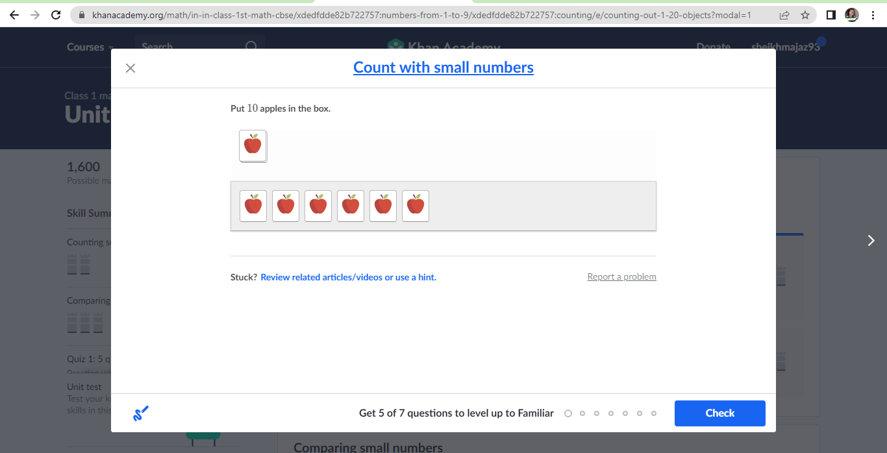

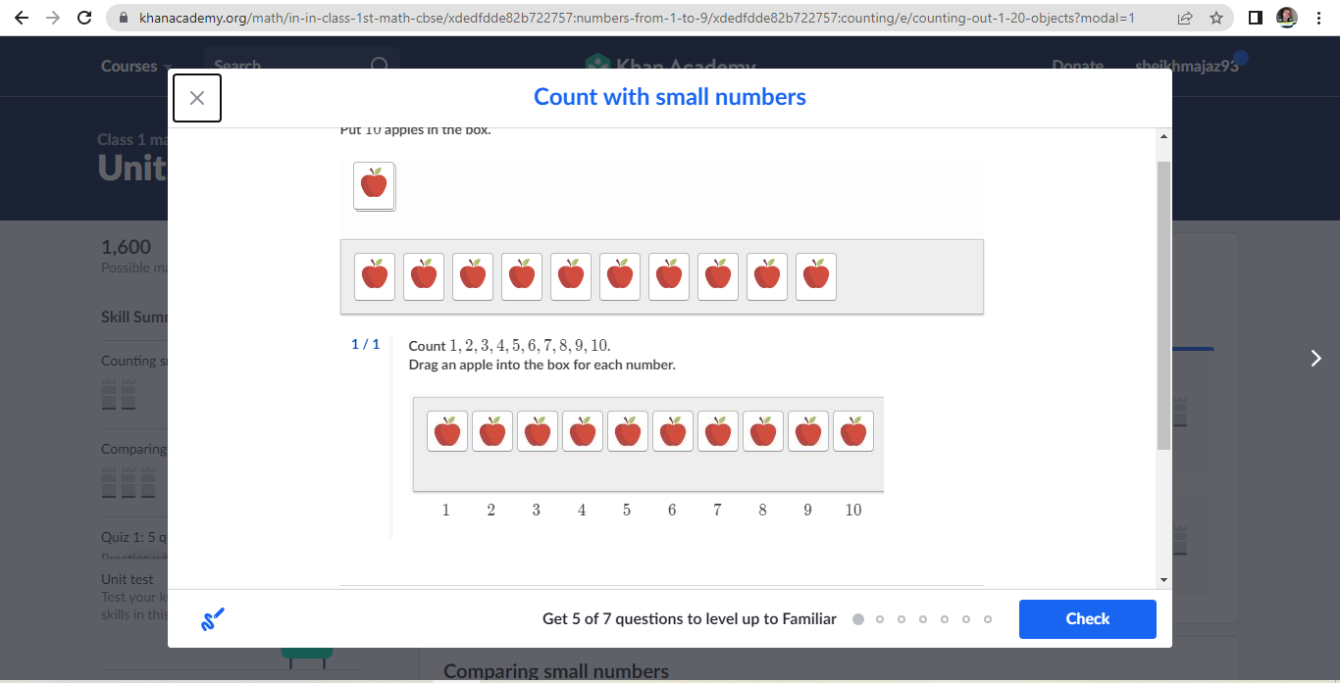

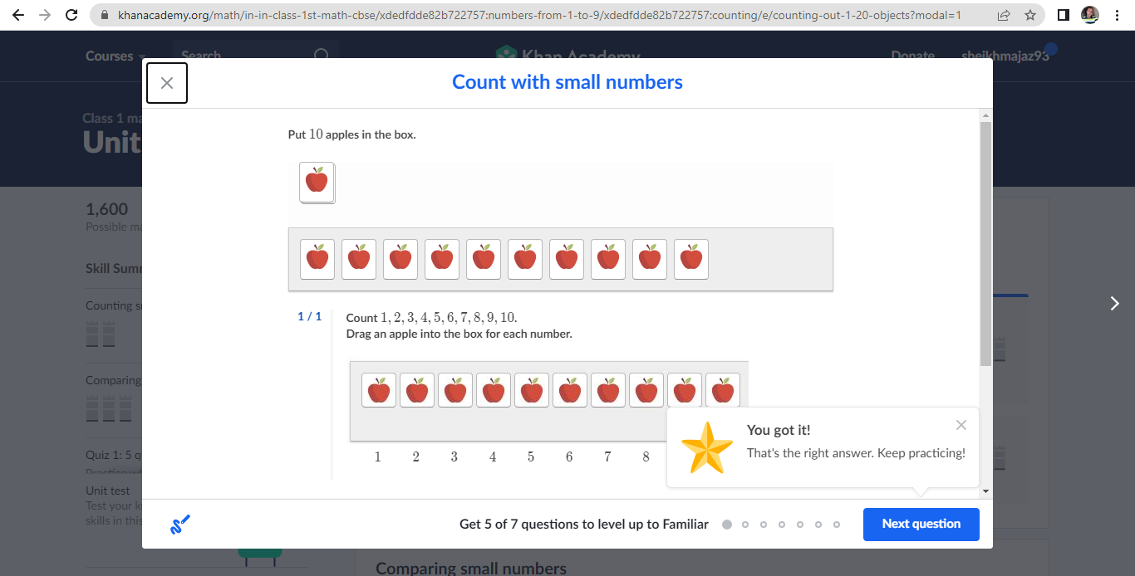

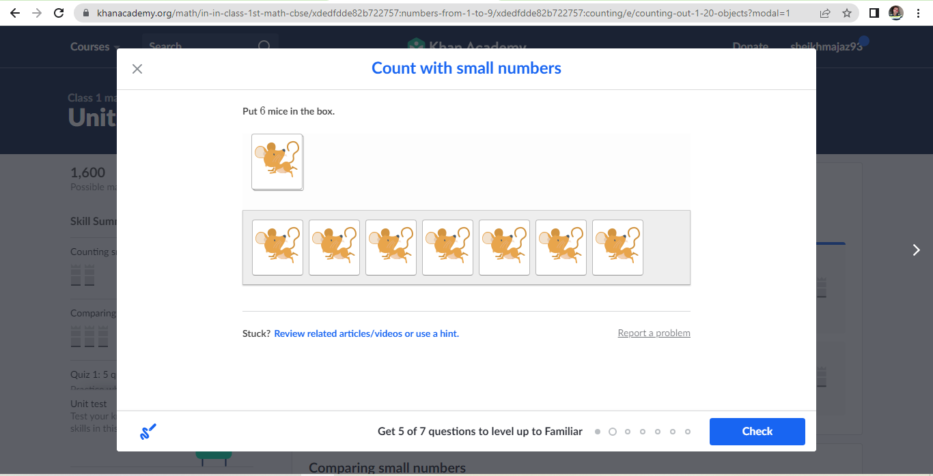

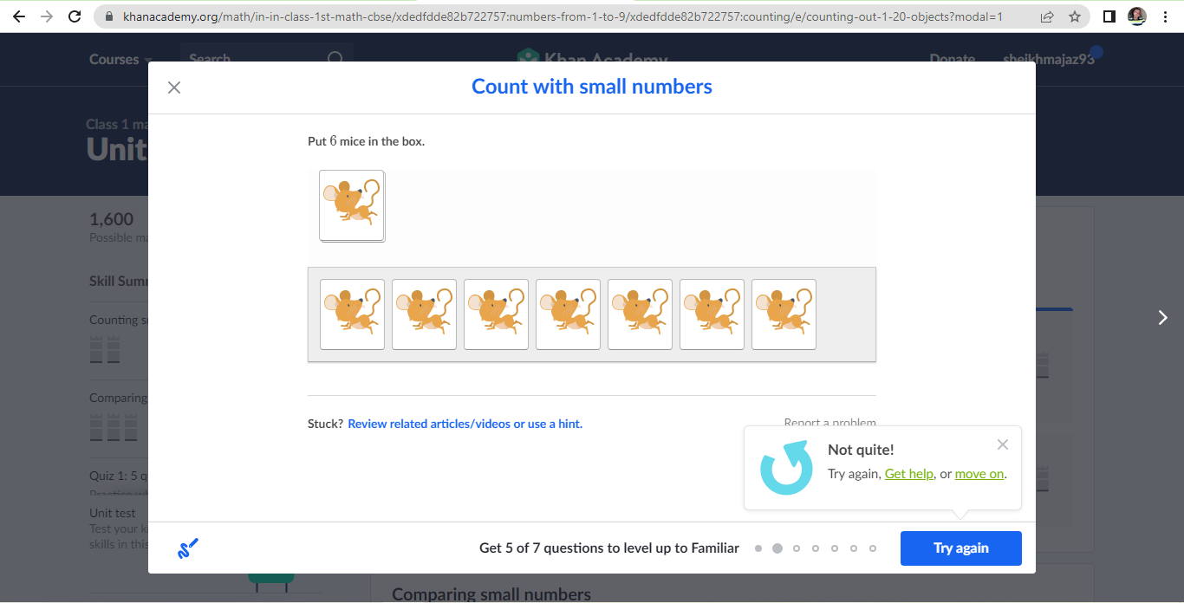

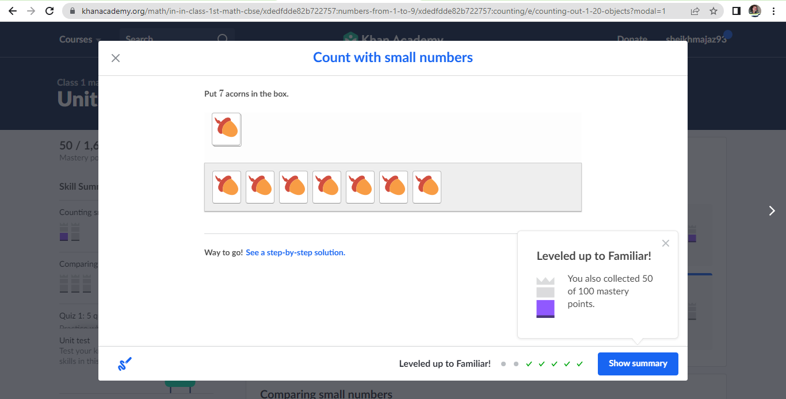

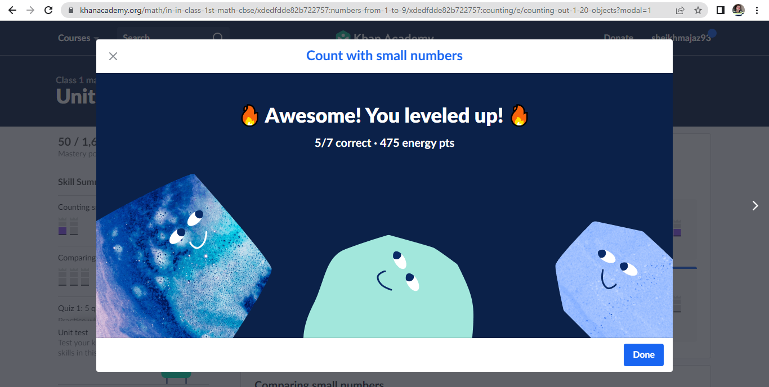

# Database Testing-

**DB- Database testing-**

SQL quires – **Select * from Testscore**

**Where Marks =** 12;

**Tables Name in your Project- (Tablename.columnname) (Join)**

**(schemaname)Lead_ Personalinfo.StudentName** – Name of the student

**Personalinfo.Contact** – Student/buyer/users contact Info

**Personalinfo.AcademicDetails**  – School/college Name

**Personalinfo.Last Year Score** –Last year academic score of the student

**Personalinfo.RegistrationDate**  **–** Dateof registration

**(schemaname)Plan_Courseinfo.CourseName –** Name of the course

**Courseinfo.CourseDuration –** Total Course Duration

**Courseinfo.CoursePrice –** Cost/Price of the course

**Courseinfo.LastYearResult –** Total Number of student pass for this course last year

**Q. Where you have used join quires?**

* **Answer-** In project, I have two table for join
* **Personalinfo** - User/ Student Personal details will store (StudentName = PK)
* **Courseinfo** – Course information which is offered to students/User (StudentName =FK)
* **Inner Join –** It is the most common type of join. SQL Server INNER JOINS returns all rows from multiple tables where two table contains common values in the join condition is met.
* **Ex**. Select TN1.CN1, TN1.CN2, TN2.CN1, TN2.CN2

From **Personalinfo** (TN1)

INNER JOIN **Courseinfo** (TN2)

ON (TN1.CN) TN1.StudentName (PK) = (TN2.CN) TN2. StudentName (FK)

2.

**a)** **TransactionDetails (TN1) - PaymentMethod(CN)**

**b) CourseDetails (TN2) - PaymentMethod (CN)**

# API Testing-

**Khan Academy** - **Front end** **user 1**🡪 Service (Book a Demo class)

**Khan Academy system Server**- Demo details for class-

**Khan Academy** - **Front end** **user 2**🡪 Service (Book a Demo class)

**Khan Academy** - **Front end** **user 3** 🡪 Service (Book a Demo class)

# User story- Book a demo class form API

**Description-** For New User/Student/Parent a book a demo lecture facility is available when Buyer/ User/student interested for any course or any particular subjects class/course he/she can book a demo lecture/demo class this demo lecture/ demo class free for all user in which they can book a class as per available slots.

**Accept criteria-**

1. Student can book 1 demo class for the subject
2. Student can request multiple demo lectures for multiple courses
3. 1 demo lecture is valid for 1 course only
4. Student can cancel the demo lecture
5. Student can postpone the demo date
6. Demo lectures all information is visible at students log in

**Developer provide-**

1. GET Request- **172.10.21.130:8080/khanacademy.org/profile/me/courses /api/Book_democlass?SelectClass= Class6**
2. **172.10.21.130:8080/khanacademy.org/profile/me/courses /api/?StudentID= 765**
3. API Key- Identgjk34KAIp
4. Unit Testing – Tables, Screenshot, etc.
5. JSON Response 🡪

“StudentID” : “256”,  
 Name – Smith Wilson

Class - 5th std

Mail – smithW453@yahoo.com

“DemoClassName” : “Mathematics”,  
 Time – 4:00 Pm

Date – 16th oct 2022

Class – 4th std

1. Verify response of GET method 🡪 Expected Result = Response should be generated
2. Verify data & count of GET method 🡪 Expected Result = Response should be generated data & count which unique
3. Verify attribute of GET method 🡪 Expected Result = Attribute should be booking time, booking date, booking class
4. Verify different status code GET method 🡪 Expected Result = 200-0k
5. Verify GET method by passing different **Select class** = Class 1 🡪 Expected Result = 200-0k & response will be generated with booking time, booking date, booking class
6. Verify GET method by passing different **Select class** = Class 2 🡪 Expected Result = 200-0k & response will be generated with booking time, booking date, booking class
7. Verify GET method by passing different **Select class** = Class 3 🡪 Expected Result = 200-0k & response will be generated with booking time, booking date, booking class
8. Verify GET method by passing different **Select class** = Class 4 🡪 Expected Result = 200-0k & response will be generated with booking time, booking date, booking class
9. Verify GET method by passing different **Select class** = Class 5 🡪 Expected Result = 200-0k & response will be generated with booking time, booking date, booking class
10. Verify GET method by passing different **Select class** as null/blank 🡪 Expected Result = 400-Bad request
11. Verify GET method by passing invalid **Select class** = philosophy 🡪 Expected Result = 400-Bad request
12. Verify GET method by passing invalid **Select class** = school name 🡪 Expected Result = 400-Bad request
13. Verify GET method by passing invalid **Select class** = XYZ 🡪 Expected Result = 400-Bad request
14. Verify GET method by passing wrong URL/URI **Demo Class Name** as null/blank 🡪 Expected Result = 404-Not found
15. Verify GET method by passing wrong Barrier token/API Key 🡪 Expected Result = 401-Unatuorized
16. Verify by changing GET method into another method 🡪 Expected Result = 405-Method not allowed

**Questions Ask in Interview –**

1. What is last US you have tested
2. What is last defect you have raised in your project
3. What is last API you have tested and what is these
4. What is discussion you have done in last retrospective meeting
5. What is the Join and where you have used the join?